KX3 External Tuning Knob w/Switches
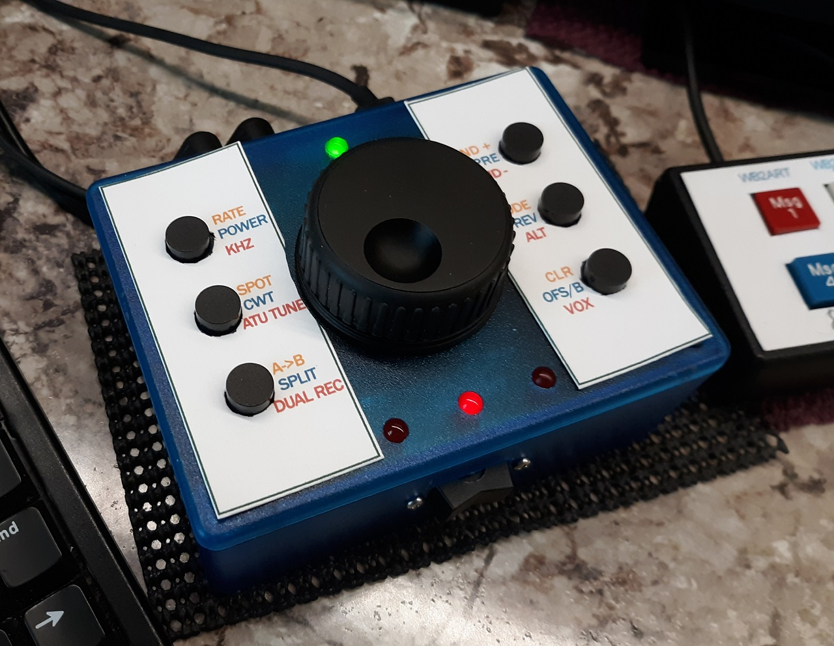
Please read all instructions before starting assembly.

Parts List
 | Description | Qty | Digikey P/N | Mouser P/N
□ | CAP ALUM 1UF 20% 50V RADIAL | 4 | 493-17436-1-ND | 647-UST1H010MDD1TE
□ | CAP CER 0.33UF 50V X7R RADIAL | 1 | 399-13992-ND | 81-RDER72A334K1K1H3B
□ | CAP CER 0.1UF 50V X7R RADIAL | 1 | 399-4329-ND | 81-RDE5C1H104J2K1H3B
□ | DIODE GEN PURP 50V 1A DO41 | 1 | 641-1310-1-ND | 621-1N4001
□ | CONN IC DIP SOCKET 16POS GOLD | 1 | ED3016-ND | 571-2-1571552-4
□ | IC TRANSCEIVER FULL 2/2 16DIP MAX232 | 1 | 296-1402-5-ND | 595-MAX232N
□ | SWITCH PUSH SPST-NO 0.1A 32V | 6 | (see note on colors) | (see note on colors)
□ | SWITCH SPDT CENTER OFF (optional) | 1 | EG4307-ND | non-stocked
□ | LED GREEN DIFFUSED T-1 3/4 (optional) | 1 | 160-1852-ND | 859-LTL-5233
□ | LED RED DIFFUSED T-1 3/4 T/H (optional) | 3 | 160-1127-ND | 859-LTL-4223
□ | CONN JACK STEREO 3.5MM R/A | 2 | CP1-3523N-ND | 490-SJ1-3523N
□ | IC REG LINEAR 5V 1A TO220-3 LM7805 | 1 | 296-47192-ND | 926-LM7805CT/NOPB
□ | CONN PWR JACK 2X5.5MM SOLDER | 1 | CP-102A-ND | 490-PJ-102A
□ | CONN HDR 40 POS 0.1 GOLD PCB FEMALE | 2 | HDR100IMP40F-G-V-TH-ND | 200-CES14001TS
□ | CONN JUMPER SHORTING .100" GOLD | 2 | S9337-ND | 571-4-881545-2
□ | OPTICAL ENCODER RPG SMT 120CPR | 2 | -------------------- | 630-HRPG-ASCA-57F
□ | BOX PLASTIC BLK 4.43"L X 3.33"W | 1 | (See note below) | (See note below)
□ | BLUE PILL MODULE | 1 | EBAY | EBAY
□ | CONN HEADER VERT 40 POS 2.54MM MALE | 1 | S1012EC-40-ND | 571-9-146278-0
□ | RES 470 OHM 1/4W 5% AXIAL (optional) | 4
□ | RES 68K OHM 1/4W 1% AXIAL (optional) | 1
□ | RES 10K OHM 1/4W 5% AXIAL (optional) | 1
□ | RES 2.7K OHM 1/4W 5% AXIAL (optional) | 1
□ | 4-40 3/8” MACHINE SCREW | 1
□ | 6-32 1/4” NYLON screw, (for LM7805 - optional) | 1
□ | 3/16” x 3/16” NYLON SPACERS | 4 | (See note below)
□ | PAPER TEMPLATE | 1
□ | PCB | 1

P/N's for pushbutton switches
Digikey P/N Color Mouser P/N
401-1972-ND White 611-D6R00F1LFS
401-1973-ND Gray 611-D6R10F1LFS
401-1974-ND Yellow 611-D6R30F1LFS
401-1975-ND Red 611-D6R40F1LFS
401-1976-ND Green 611-D6R50F1LFS
401-1977-ND Blue 611-D6R60F1LFS
401-1978-ND Black 611-D6R90F1LFS

Hammond Box colors:
Digikey P/N Color Mouser P/N
HM1546-ND Black 546-1591XXSSBK
HM3992-ND Trans Blue 546-1591XXSTBU
HM3991-ND Gray 546-1591XXSGY

McMaster-Carr
Nylon Unthreaded Spacers, 3/16" OD, 3/16" Long, Black
90176A104

Drilling the case
Before you mount any components on the pcb, do the following:
1: Take the 4 machine screws and nylon spacers and assemble, with the screws going through the nylon spacers, then the pcb, then mount on the case front.

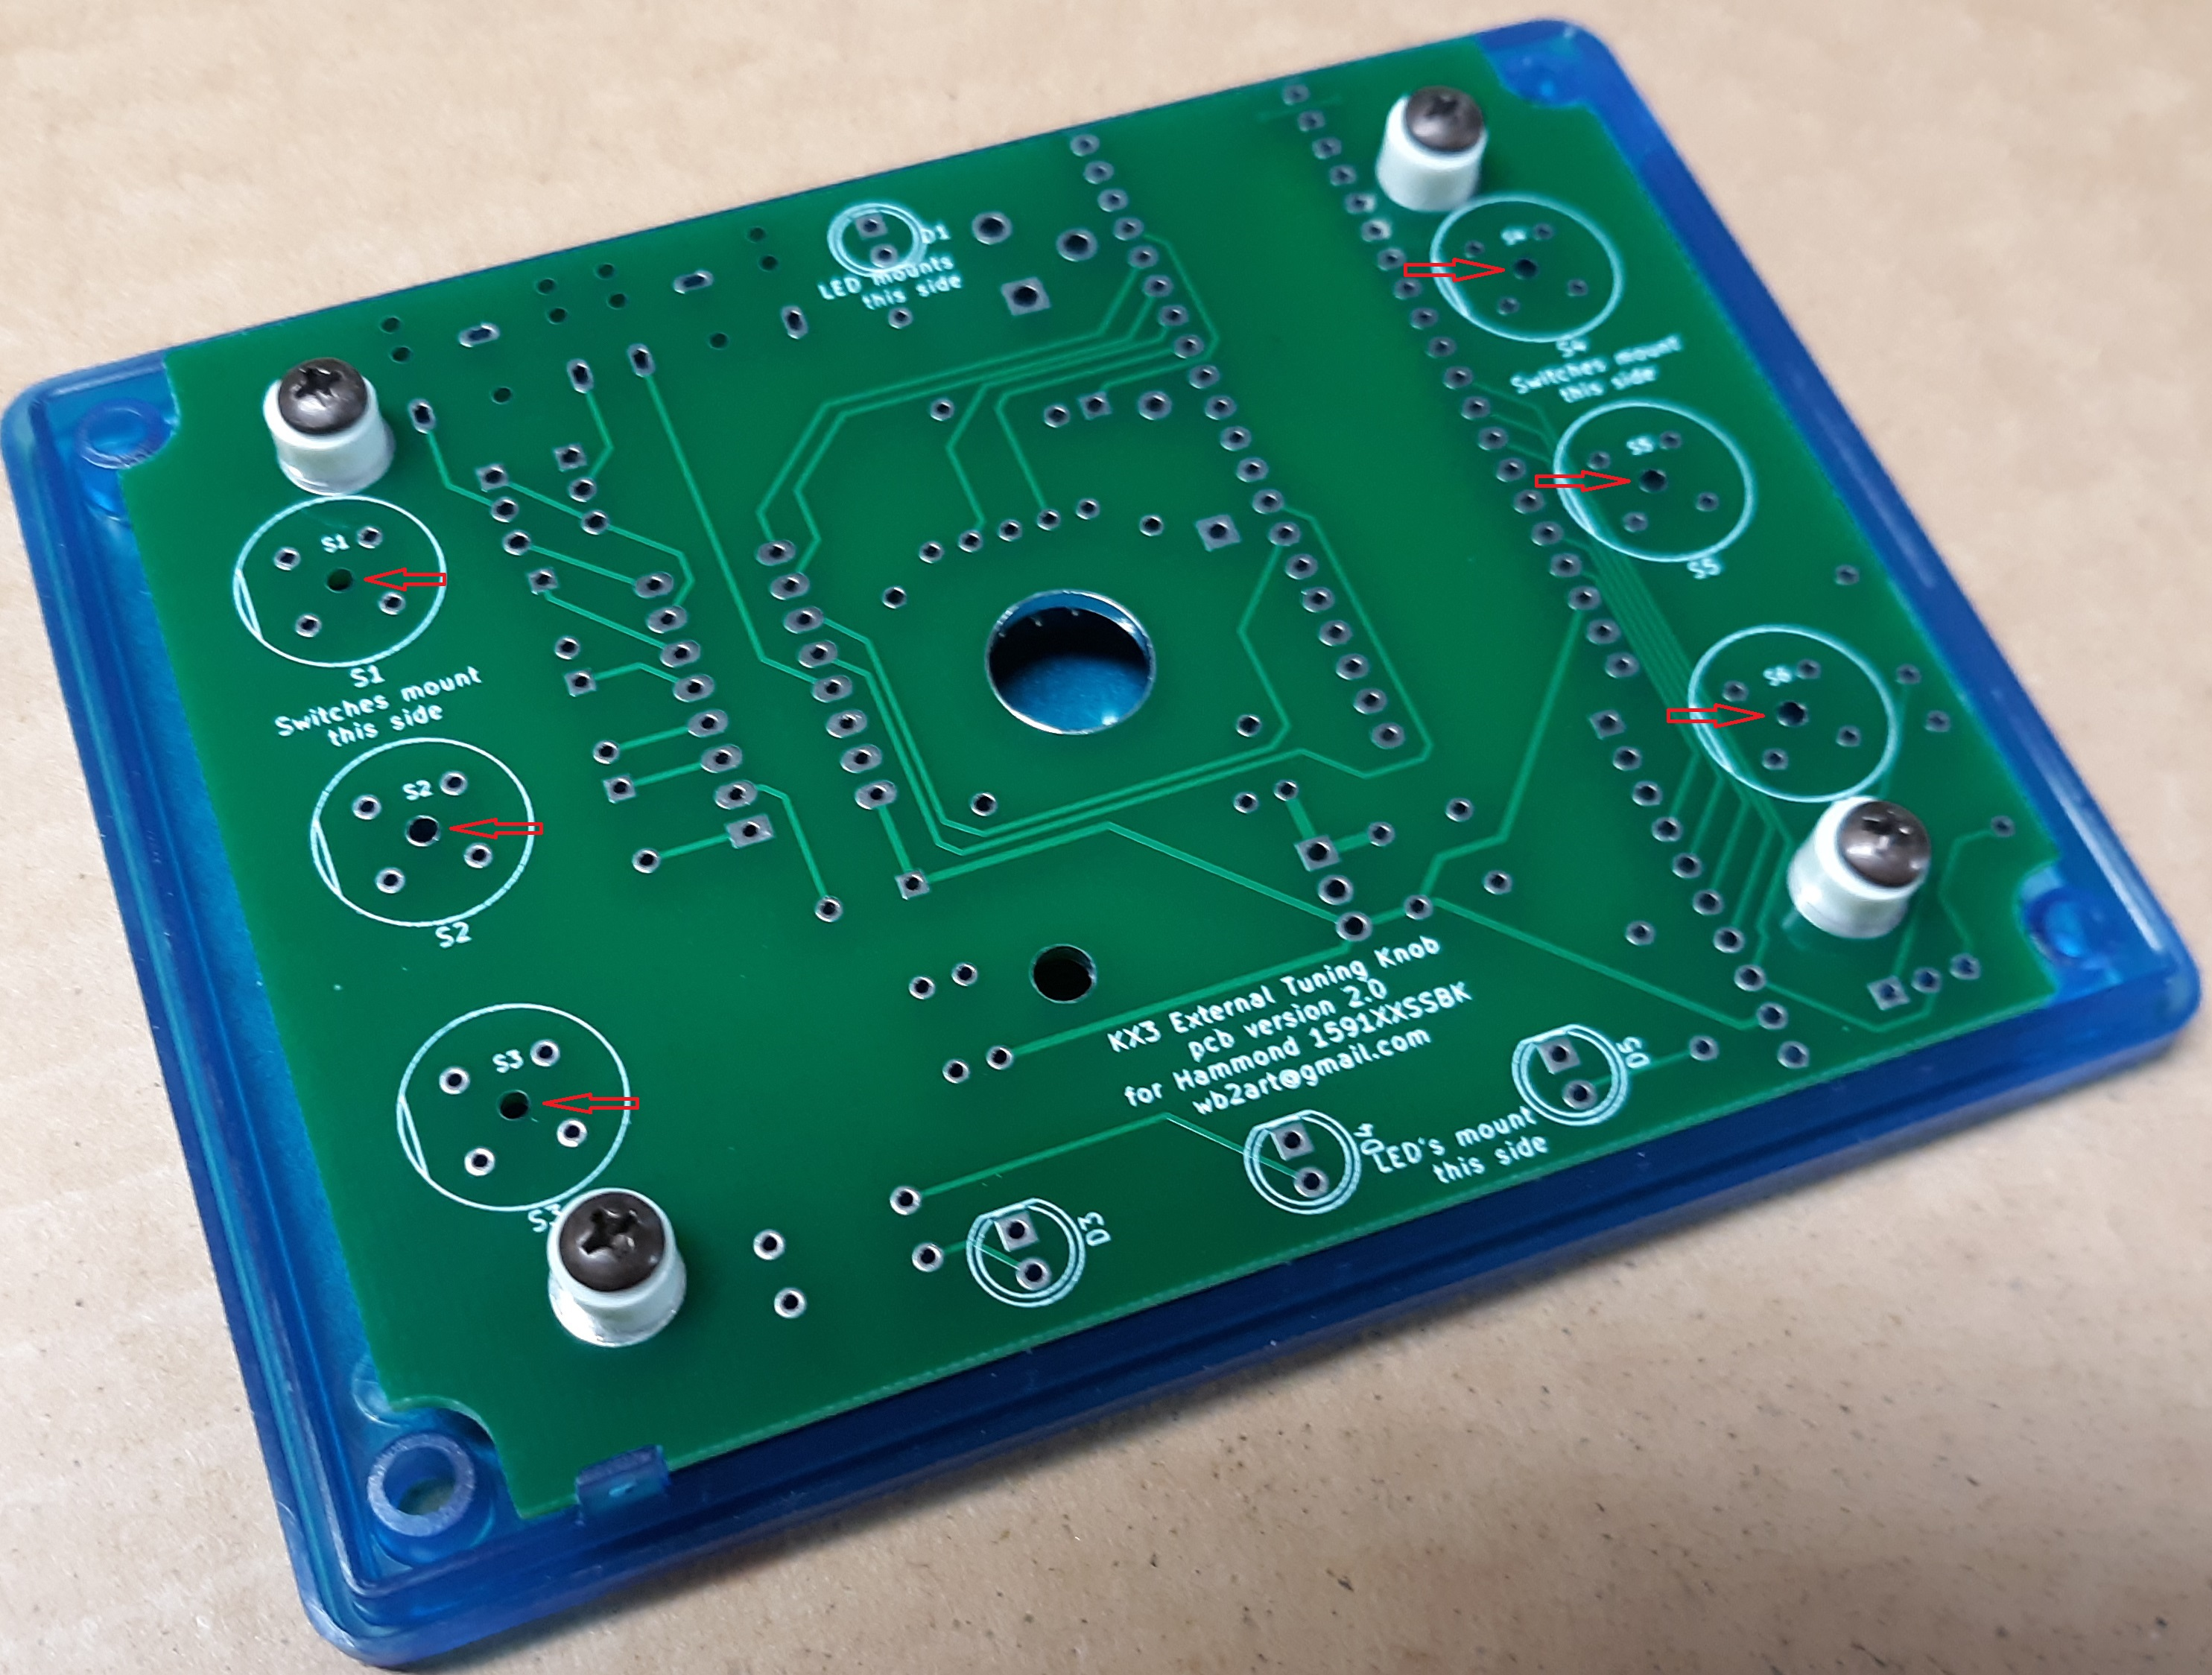
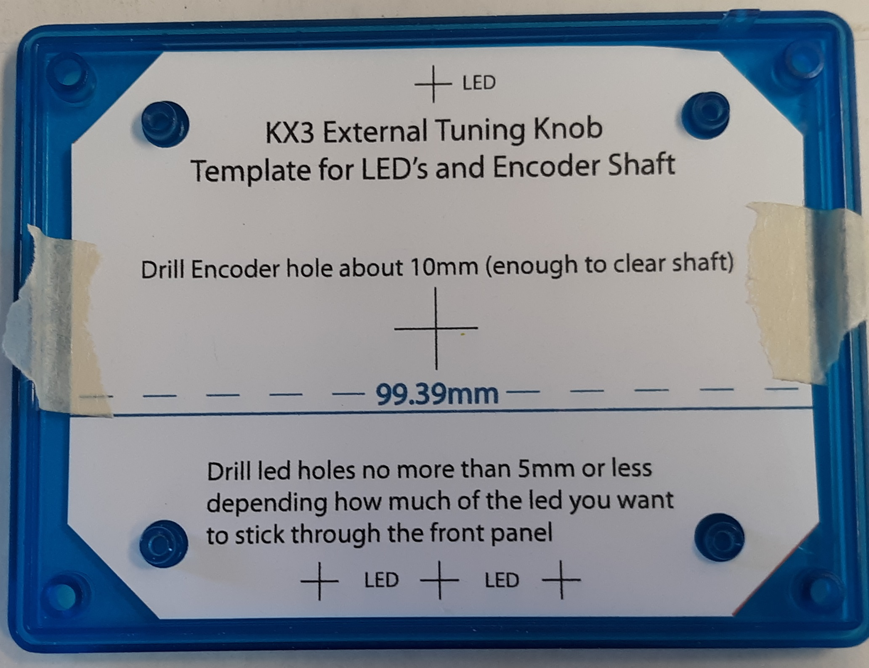
If you want, you an mount the paper template then mount the pcb on top of it.

2: Now, you can take a 1/16 inch drill and drill through the center hole in each switch. Do this in a drill press if possible. This will align the switches with the holes in the case. NOTE: You may mount all 6 or any of the switches.

3: Remove the pcb from the case front. Use the 1/16 inch drill to locate the power led hole at the top, the 3 bottom led holes, and the encoder hole in the center. (The 3 bottom led's are optional, as is the power led)

4: Drill all holes to the proper size. See template for LED and Encoder hole sizes. Holes for the switches are 9mm (0.354). They may be drilled slightly smaller and enlarged with a hand reamer. If using a hand reamer, work from the inside of the front panel. Do not make them too large!

Assembly Component Side
The picture is the component side of the pcb.

1: Most of the components mount on the back of the pcb.

470 ohm (R1,R2,R3,R4), 10K ohms (R7) and 68K ohms (R6) and 2.7k (R5) resistors.

1N4001 diode (D2) (watch polarity).

3 - 'U' shape wires at TP1, TP2 and TP3.

0.33uf (C6) and 0.1uf (C5) capacitors.

LM7805 (use 6-32 nylon screw, cut to length then melt to hold in place).

16 pin socket for Max232 (notch points to bottom of PCB).

4 - 1uf electrolytic capacitors (C1,C2,C3,C4) (watch polarity)

.100 male header pins for Blue Pill module (or solder directly to pcb using .100 male header pins. Header pins are included with the Blue Pill Module)

Cut and install 3 - .100 male headers, 3 pins each at J4,J5 and J8.

Cut and install 1 - .100 male headers, 2 pins at J6.

install 2 - .100 jumpers across pins 1 & 2 of J4 and J5.

Cut and install 1 - .100 male header, 9 pins (J7)

install 2 - 20 pin female headers at the location for the Blue Pill Module. Count off 20 pins on each female header and pull the 21st pin out of the housing. Then cut between the 20th and 22nd pins, so you have 2 - 20 pin female headers.

install power jack at J3.

install TRS jacks at J1 and J2.

install encoder so the shaft extends out the FRONT of the pcb. Secure with lock washer and nut.

Assembly Switch and LED Side
The picture is the switch & led side of the pcb.

2: The only components on the front of the pcb are the 6 switches and LED's. The encoder shaft extends through the front of the pcb. S1 through S6, the flats face either left or right.
Note: You do not need to install all the switches, if you did not drill all 6 case holes.

install switches S1 – S6 with flat portion of the switch facing left or right.

Mount the pcb with the led leads extending to the back of the pcb, do not solder. Make sure the led(s) pokes through the cover. Mount the pcb to the front panel Push the leds from the component side to the holes in the front panel. If not enough of the led shows through the front panel, the take off the pcb and drill holes slightly larger. At 5mm, the leds will show their maximum length . Remount the pcb and solder from the back of the pcb.

install Max232 (watch the notch!)

install Blue Pill board – usb connector faces the rear of the case.

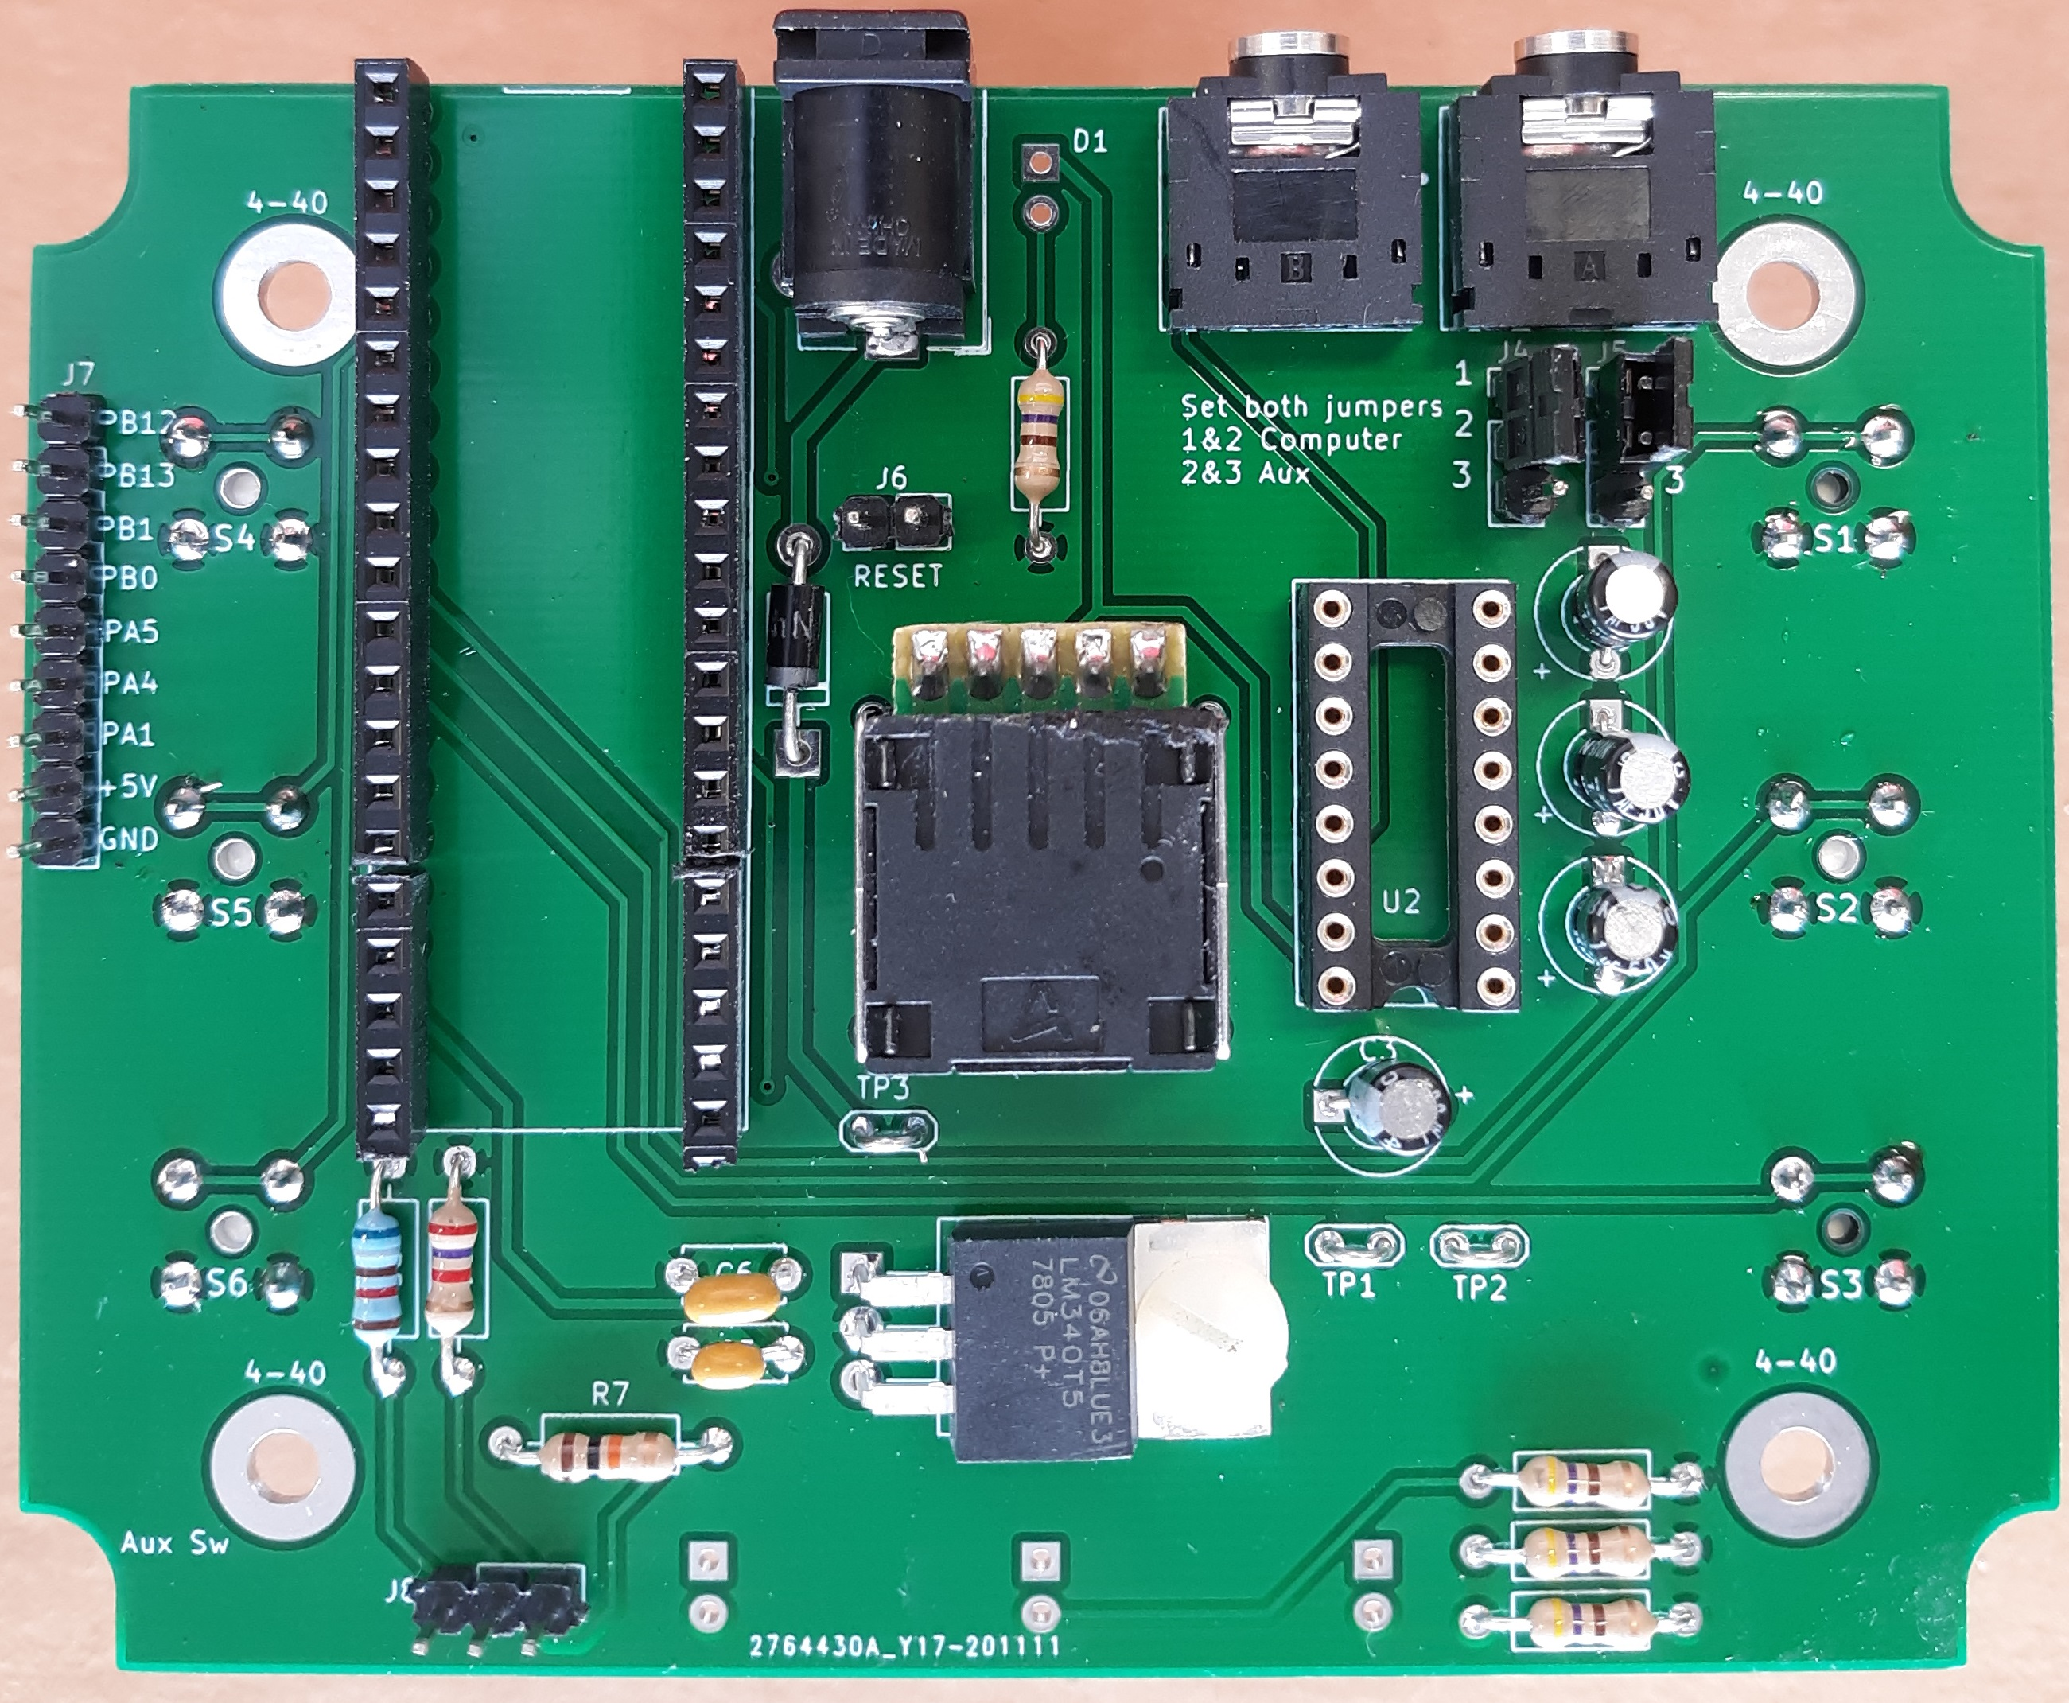
Completed rear of pcb / led's, max232,blue pill, not installed

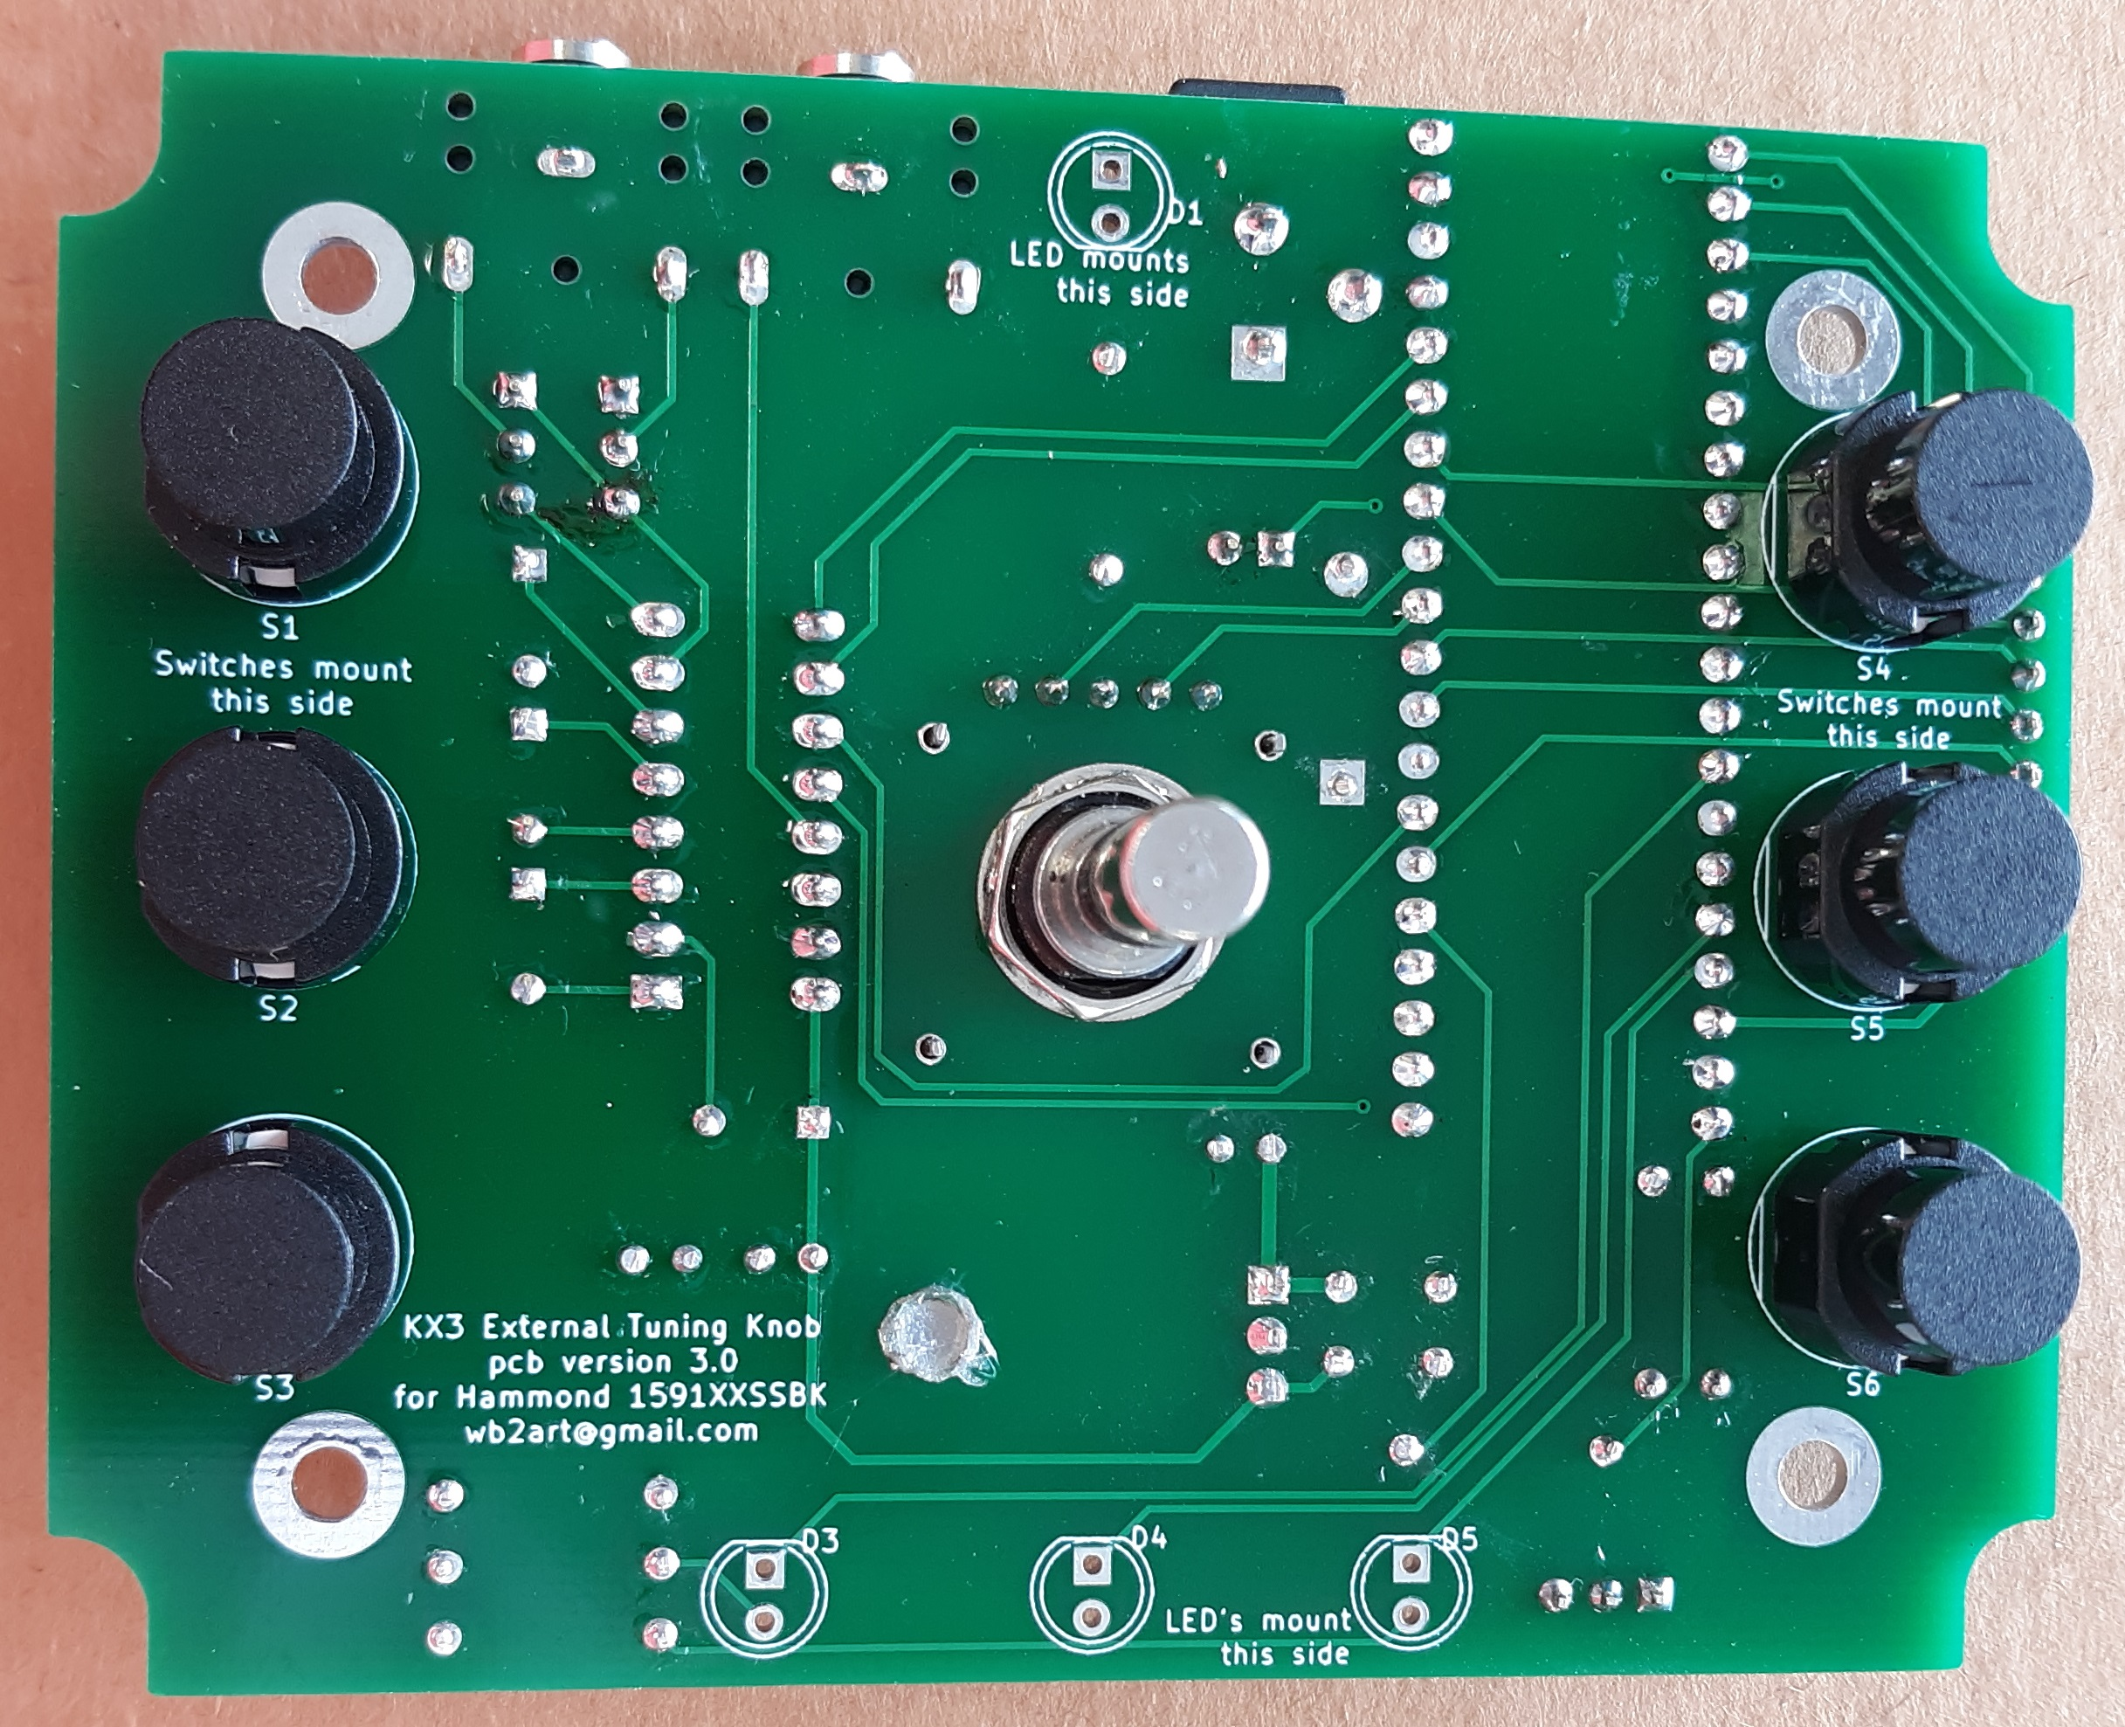
Completed front of pcb / no led's installed
Note the melted nylon screw in the LM7805 mounting hole.
Not really necessary, as the pcb has no heat sinking.
Leave out or install as you wish.
Make sure when you mount the switches, you look at them from a few angles, to make sure they are flat to the board and not tilted. They should line up in the vertical and horizontal directions.

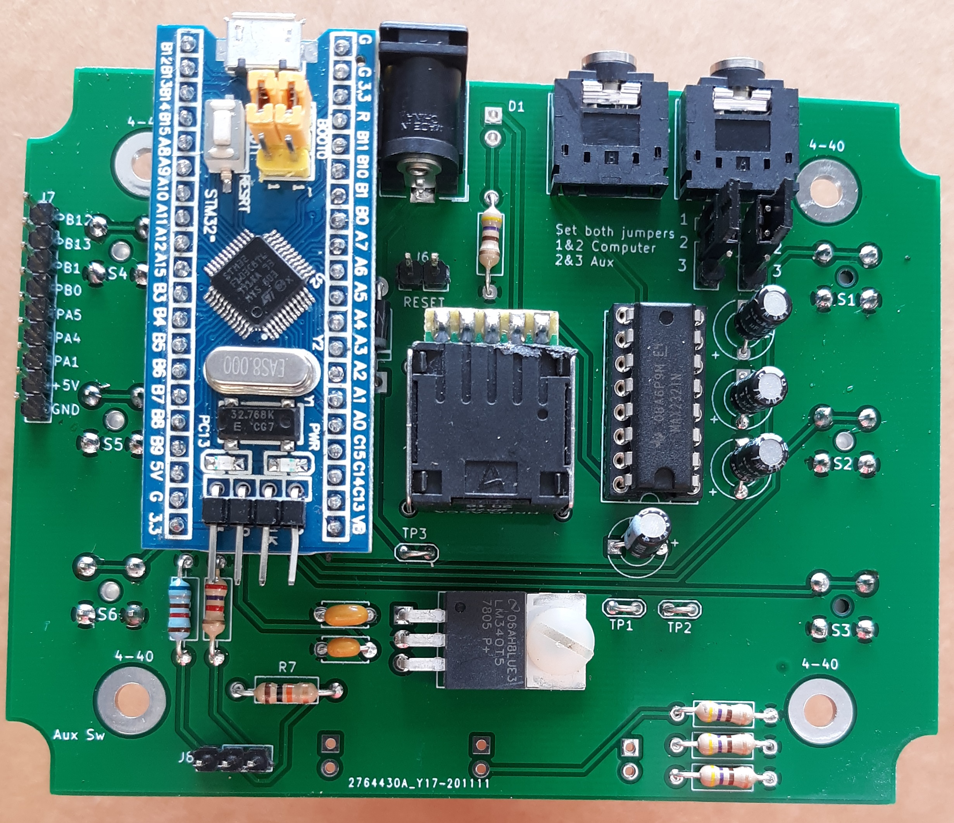
Assembled pcb / no led's installed

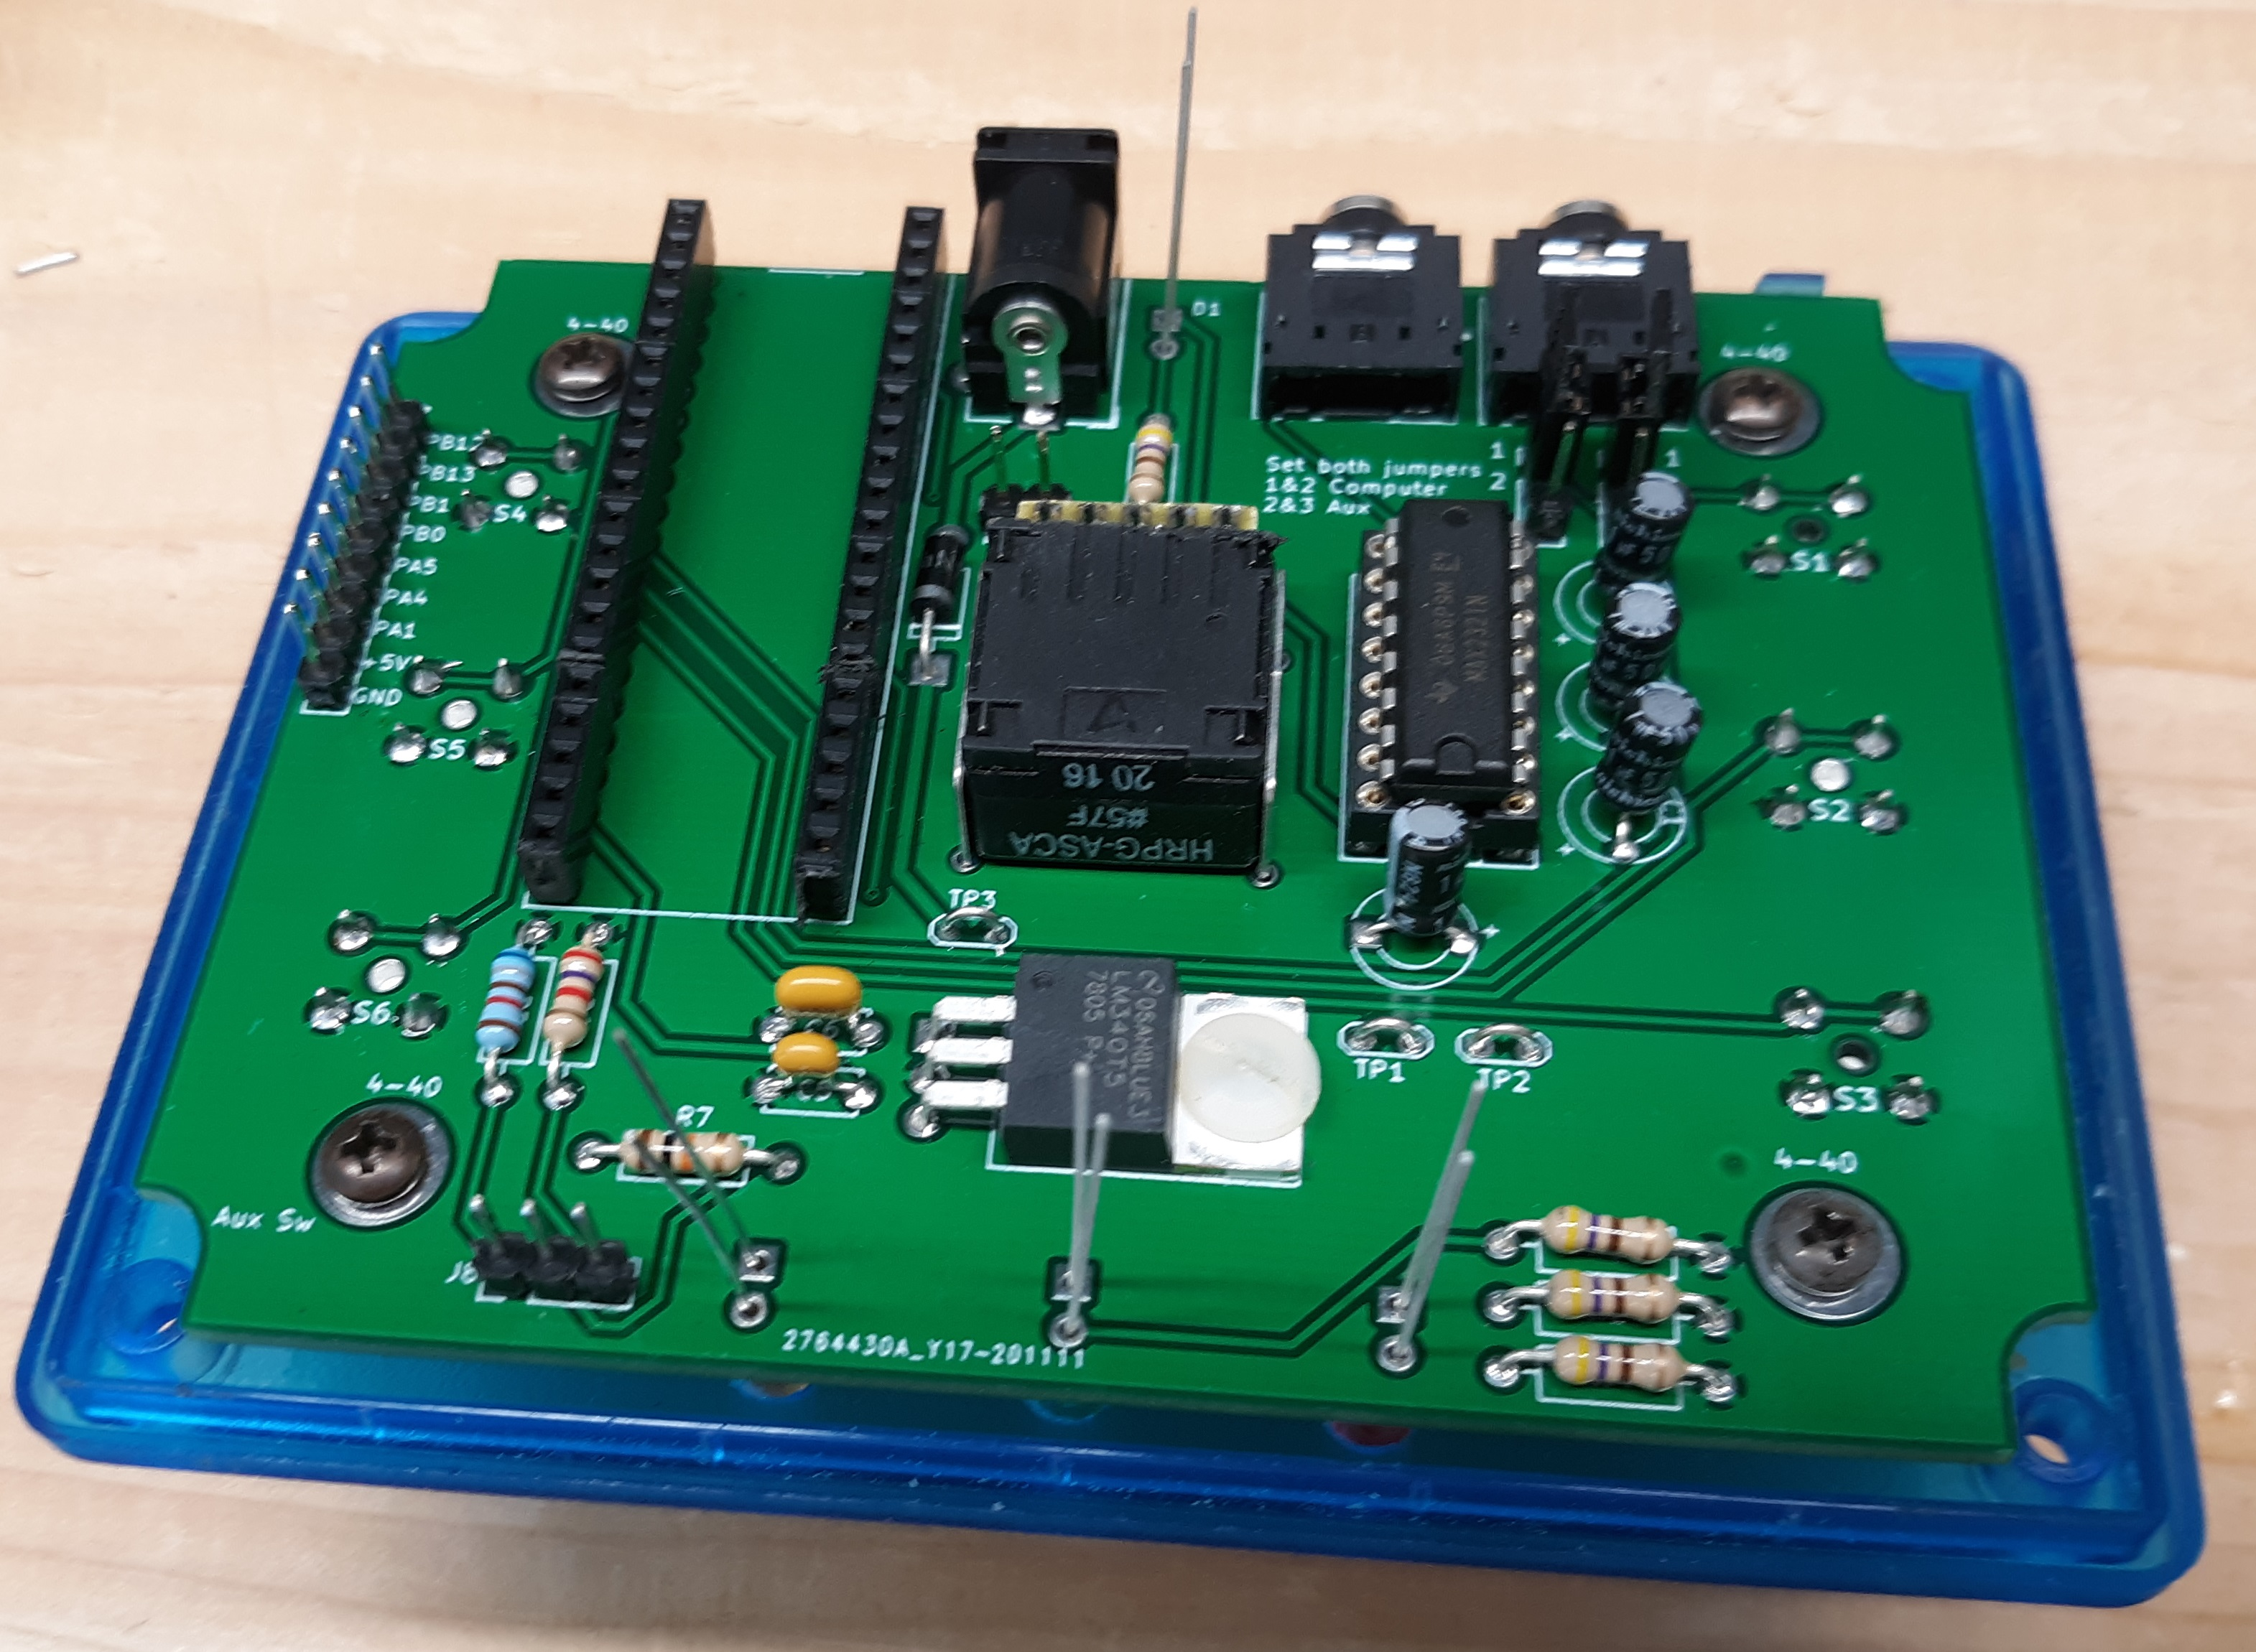
led's ready to be soldered / make sure to align through the drilled holes in the front panel before soldering

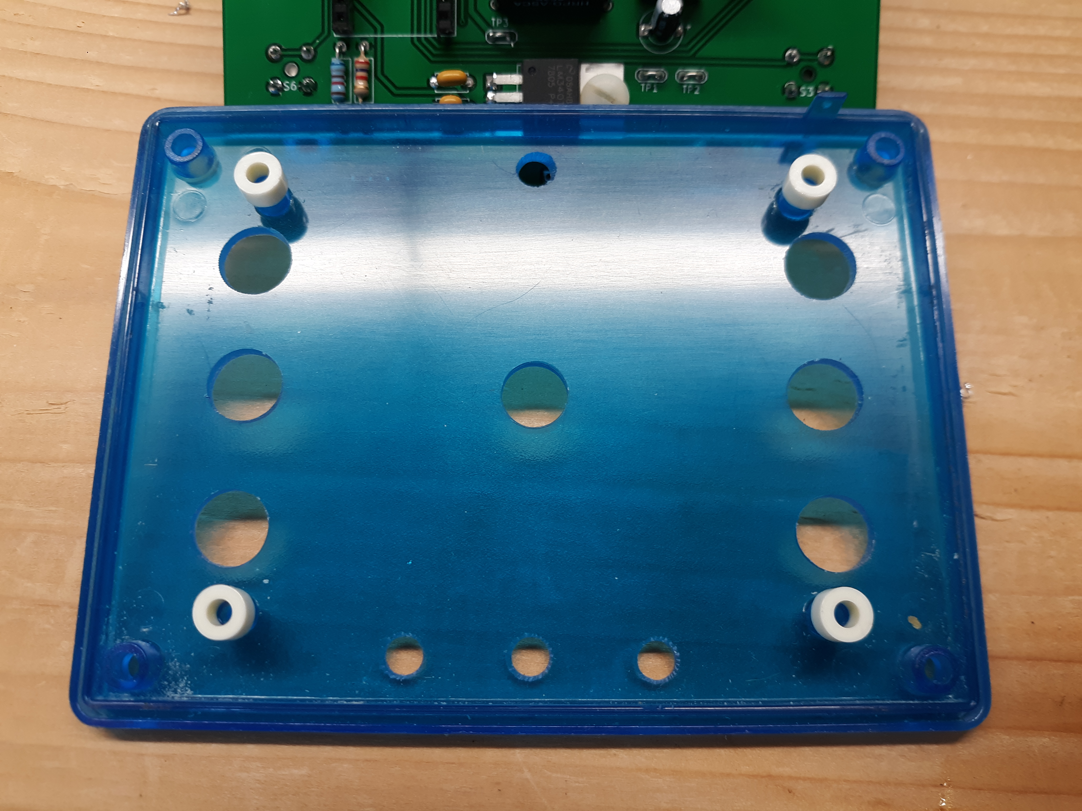
front panel rear view after drilling / I used a bit of super glue to fasten the spacers to the front panel / makes it easier to install pcb

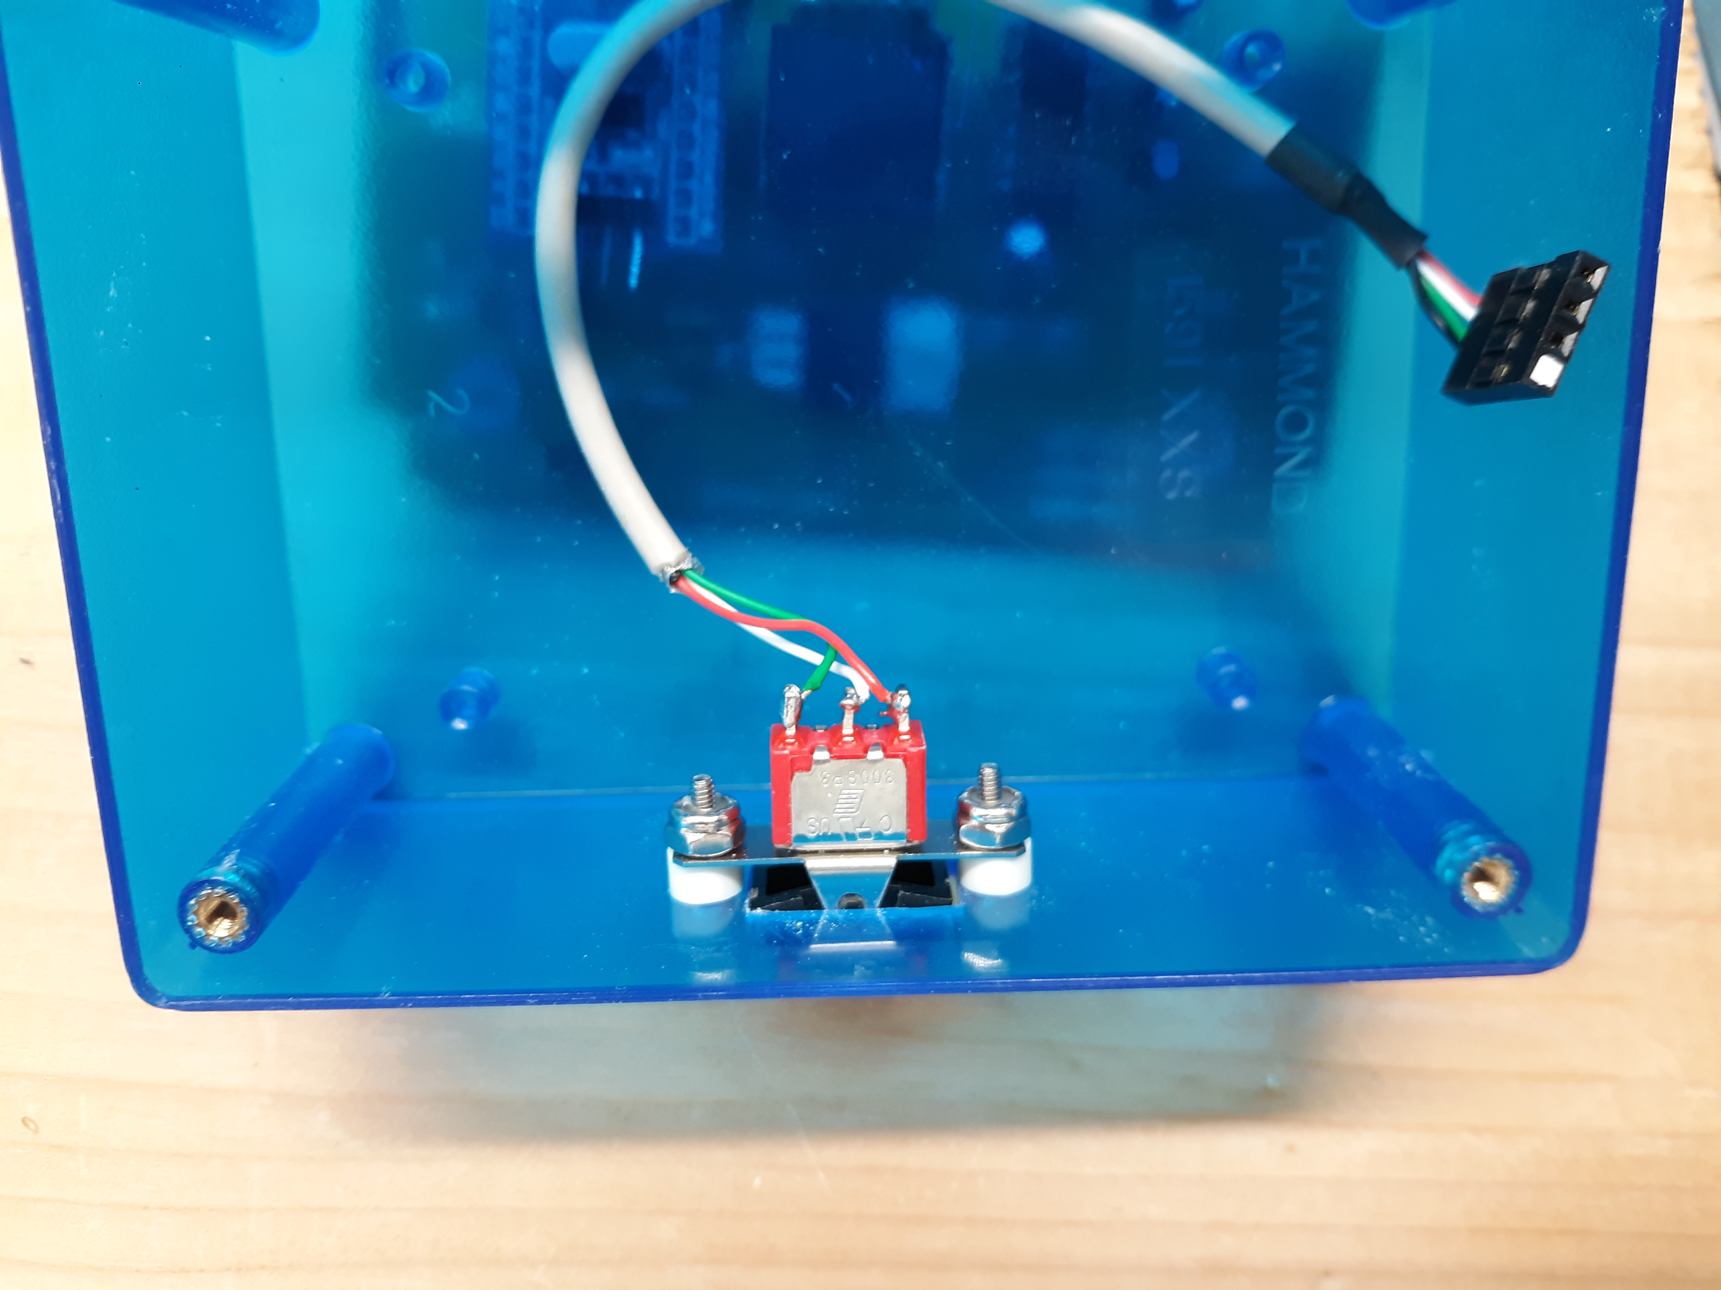
Auxiliary switch installed with .140 spacers and 2-56 hardware
the cable is just one I had around, as it had the female socket already mounted.

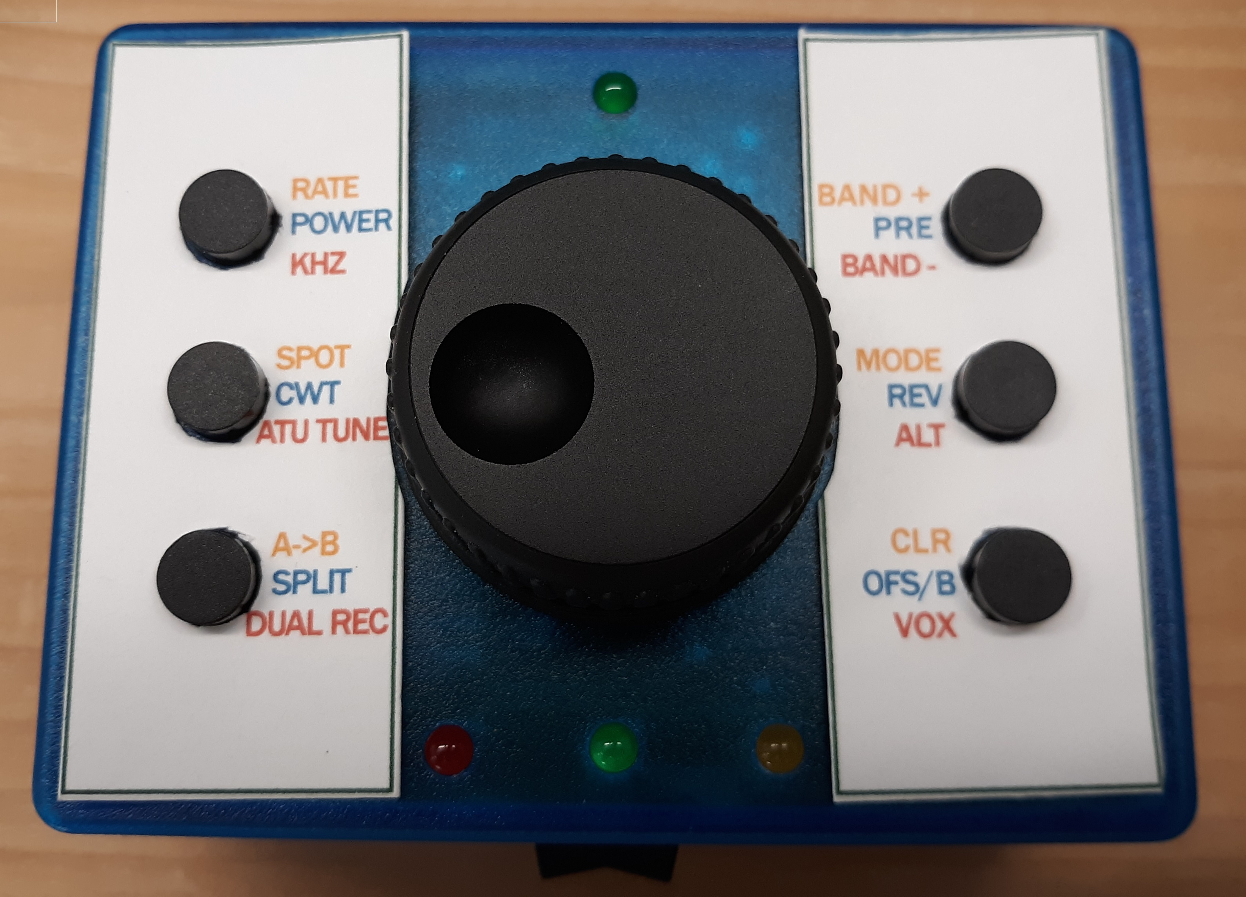
My completed tuning knob. I used a green led to indicate vfo A, and a red led to indicate vfo B. The yellow led indicates the tuning knob is bypassed, and only the 2 serial ports are active to transfer data between the KX3 and computer. The button and tuning knob are locked out. (Useful when operating with WSJT-X)

Setting up the Blue Pill module

1: Go to: https://circuitdigest.com/microcontroller-projects/programming-stm32f103c8-board-using-usb-port
2: Follow their instructions on setting up the USB Bootloader on the Blue Pill.

Loading the program into the Blue Pill module

1: You must have the Arduino IDE loaded on your computer, along with the latest software from: www.wb2art.com/KX3ExtTuningKnob/
2: Under File: Preferences: AdditionalBoards Manager URLs: enter -
http://dan.drown.org/stm32duino/package_STM32duino_index.json
You can get instructions by Googling “blue pill stm32 arduino ide”.

3: Make sure you have the correct board chosen, under Tools: Board. It should be the “Generic STM32F103C series”.
4: Under Tools: Upload method choose: STM32duino bootloader
5: Under port, make sure the IDE can see the Blue Pill board. It should indicate COM(your com port) (Maple Mini).
6: Download any additional libraries as indicated in the code.

Uses
1: Turning the knob will tune the KX3 up/down in frequency.
2. The 6 switches (if installed) can be programmed for tap, double tap and hold.

